SIMATS ENGINEERING
ASSESSMENT TOOL 2

COURSE NAME: INTERNET PROGRAMMING
COURSE CODE: CSA4301

COURSE OUTCOME COVERED

CO -2 : Apply CSS layout and styling techniques to create visually appealing and responsive web interfaces, and use JavaScript to enable interactive client-side behavior. (L3)

Assessment Tool : Design Task

Weightage: 20%

QUESTIONS: Total Marks: 20

Question 1: Responsive Navigation Bar Design - Marks(4)
Suppose that an e-commerce website requires a responsive navigation bar that adapts across desktop, tablet, and mobile devices.
(a) Identify key components required in a navigation bar for an e-commerce website.
(b) Design a responsive navigation bar using appropriate CSS techniques.
(c) Demonstrate how the navigation adapts to smaller screens (e.g., hamburger menu).
(d) Evaluate the usability and suggest improvements for better user experience.
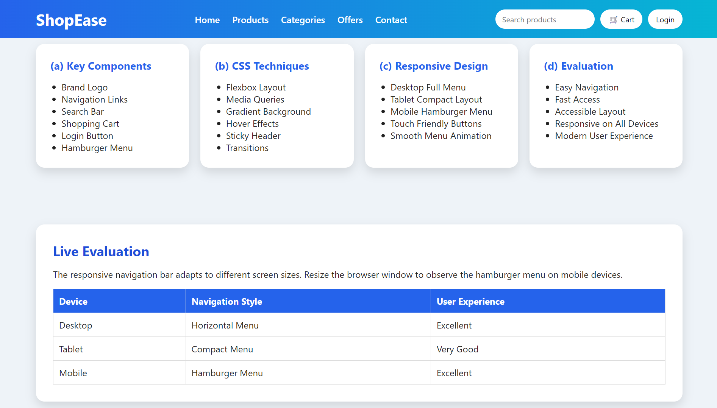

Question 2: Product Hover Effect - Marks(4)
Suppose that an e-commerce website wants to enhance user interaction through visual effects on product items.
(a) Identify suitable CSS properties for hover effects.
(b) Suggest appropriate CSS animation or transition for product interaction.
(c) Design a hover effect for a product card.
(d) Evaluate performance and user experience considerations.
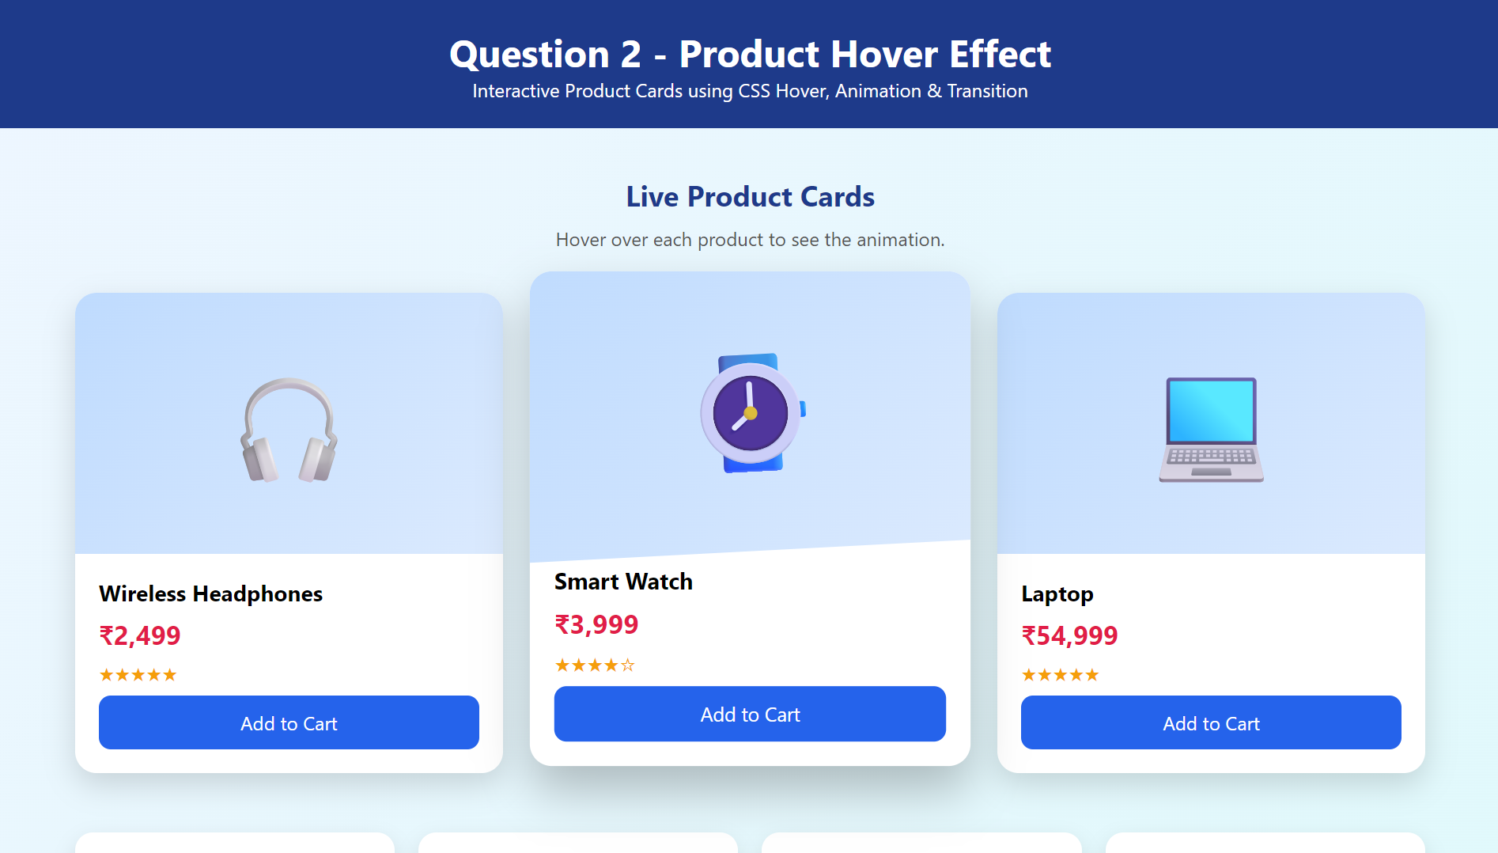

Question 3: Layout Selection (Flexbox vs Grid) - Marks(4)
Suppose that a dashboard layout needs to be designed for a web application.
(a) Identify layout requirements of a dashboard (rows, columns, alignment).
(b) Compare Flexbox and Grid based on layout needs.
(c) Choose the most suitable layout technique and justify your choice.
(d) Evaluate the scalability and responsiveness of the chosen approach.
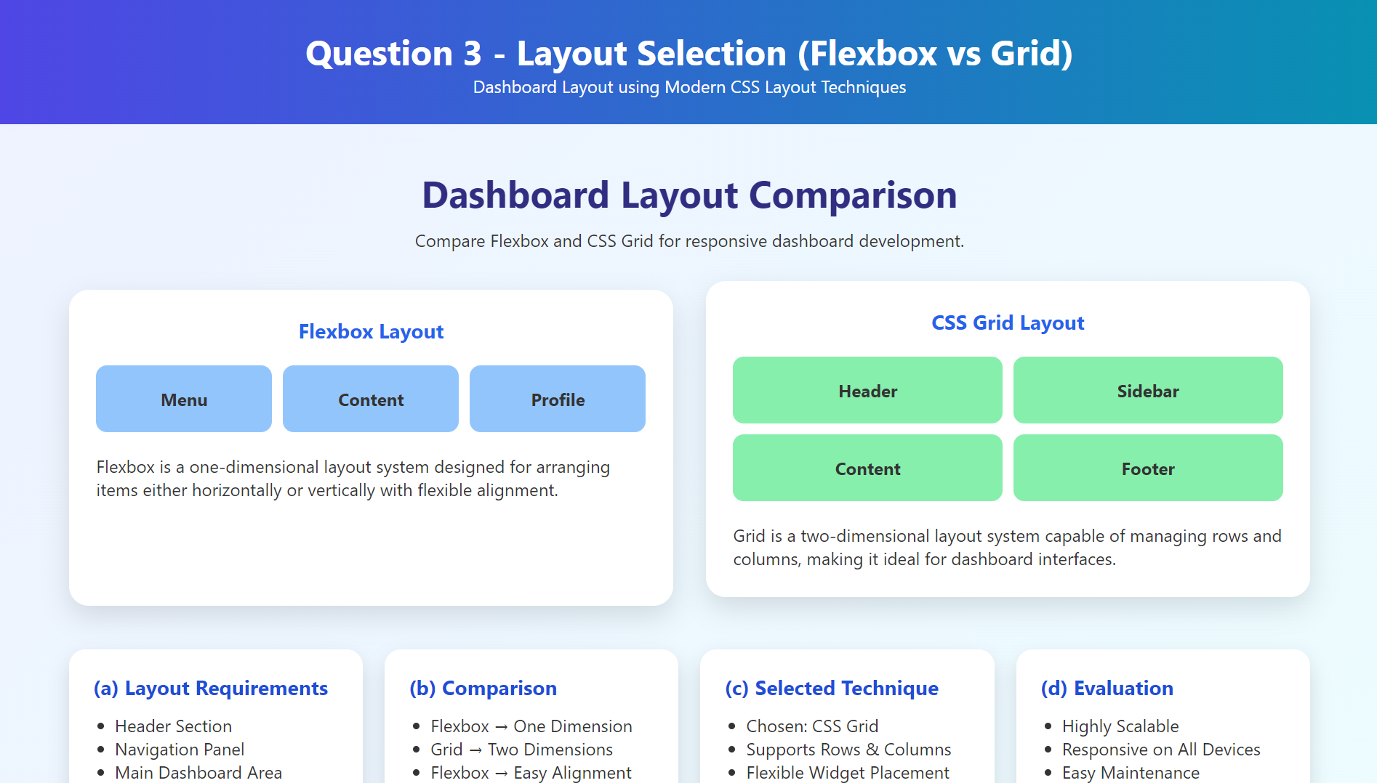

Question 4: Mobile-First Blog Layout - Marks(4)
Suppose that a blog page must be designed following a mobile-first approach.
(a) Identify key sections of a blog layout.
(b) Design a mobile-first layout using CSS.
(c) Demonstrate how the layout scales for larger screens using media queries.
(d) Evaluate accessibility and readability of the design.
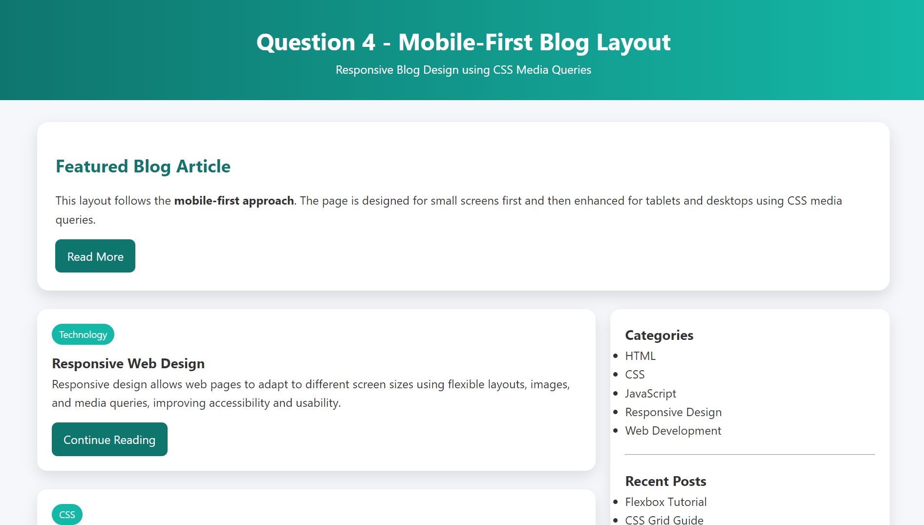

Question 5: JavaScript Event Handling for Dynamic Menu - Marks(4)
Suppose that a website includes a dynamic menu that responds to user interactions.
(a) Identify appropriate JavaScript events for menu interaction.
(b) Design event handling logic for menu toggle functionality.
(c) Implement interaction for user actions (click/hover).
(d) Evaluate performance and suggest improvements.
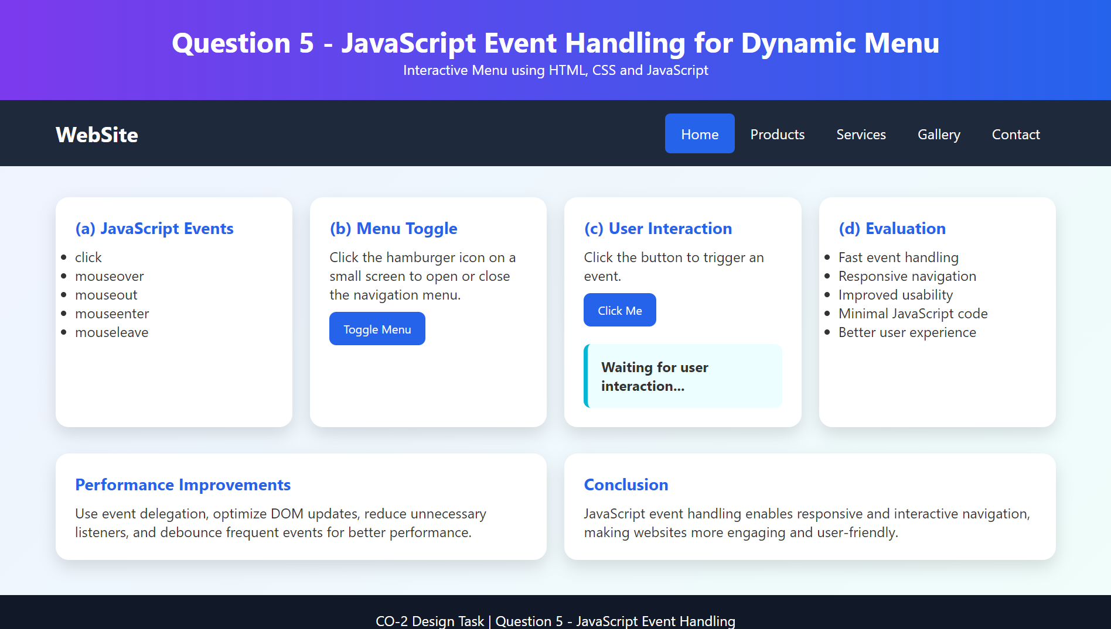

Code of Conduct:

I K Madan Mohan Reddy (192411206) (Name / Reg No) certify that this submission is my original work and that I have adhered to the guidelines specified for this assessment. I understand that any violation of academic integrity rules will result in disciplinary action.

Signature of the student:

Byreddy

RUBRICS FOR CALCULATION:

Criteria | Weightage (%) | Level 4 – Exemplary (4) | Level 3 – Proficient (3) | Level 2 – Developing (2) | Level 1 – Beginning (1)
Understanding of Concept | 25 | Demonstrates complete understanding of design requirements and concepts | Good understanding with minor gaps | Basic understanding with some errors | Poor understanding or incorrect concepts
Design / Implementation | 30 | Well-structured, efficient, and responsive design implementation | Correct implementation with minor issues | Basic implementation with inconsistencies | Incorrect or incomplete implementation
Use of Tools (CSS/JS) | 20 | Effective and advanced use of tools/techniques | Appropriate use of tools | Limited or inconsistent use | Incorrect or minimal use
Analysis & Evaluation | 15 | Insightful analysis with strong justification and optimization | Good analysis with justification | Basic analysis with limited depth | Poor or no analysis
Documentation / Clarity | 10 | Clear, well-structured, and properly presented solution | Mostly clear with minor issues | Basic clarity, missing details | Poor or unclear documentation

